ACTIVE CLASS WEEK 7

ACTIVITY 1

Here is the revised explanation tailored to an individual perspective, based on your network setup and role-playing activity:

---

**1. Network Setup:**

- **Configuration:**

- **Router0** is connected to **Switch1** and **PC1** on LAN **10.1.1.0/24**.

- **Router1** is connected to **Switch2** and **PC3** on LAN **198.168.10.0/24**.

- **Router0** and **Router1** are directly connected via a serial link.

- **Roles and Responsibilities:**

- **LAN Administrator for 10.1.1.0/24 (Ekam1):** Manages PC1 and is responsible for network configuration and connectivity within this LAN.

- **LAN Administrator for 198.168.10.0/24 (Ekam2):** Manages PC3 and oversees network configuration and connectivity within this LAN.

- **Router0 Data Plane (Ekam3):** Handles the data plane responsibilities for Router0, including routing and forwarding packets within and beyond the LAN.

- **Router1 Data Plane (Ekam4):** Manages the data plane for Router1, dealing with routing and forwarding tasks for packets within its network.

- **Control Plane (Ekam5):** Oversees the control plane for both routers, ensuring that routing information is exchanged and maintained accurately.

**2. Ping Test:**

- **Ekam1 (PC1)** sends ping requests to **Ekam2 (PC3)** to test connectivity between the two LANs.

**3. Step-by-Step Instructions:**

- **Ekam5 (Control Plane)** ensures that Router0 and Router1 are properly exchanging routing information to enable communication between the LANs.

- **Ekam3 (Router0 Data Plane)** updates the routing table in Router0 to recognize and route packets destined for LAN **198.168.10.0/24** through Router1.

- **Ekam4 (Router1 Data Plane)** updates the routing table in Router1 to recognize and route packets destined for LAN **10.1.1.0/24** through Router0.

- **Ekam1 (PC1)** initiates a ping request to **Ekam2 (PC3)**. The ping packet is forwarded to **Ekam3 (Router0)**.

- **Ekam3 (Router0)** checks its routing table, determines that the packet should be sent to **Ekam4 (Router1)**, and forwards it accordingly.

- **Ekam4 (Router1)** examines its routing table, forwards the packet to **Ekam2 (PC3)**.

- **Ekam2 (PC3)** receives the ping request and sends a reply back to **Ekam1 (PC1)**, with the packet traveling the same path in reverse.

**4. Control Plane Responsibilities:**

- **Ekam5 (Control Plane)** is tasked with maintaining up-to-date routing tables for both routers. This includes managing the exchange of routing information between Router0 and Router1 and ensuring that each router has accurate information about the networks reachable through the other. The control plane is crucial for determining the optimal path for data packets and ensuring seamless communication between LANs.

ACTIVITY2

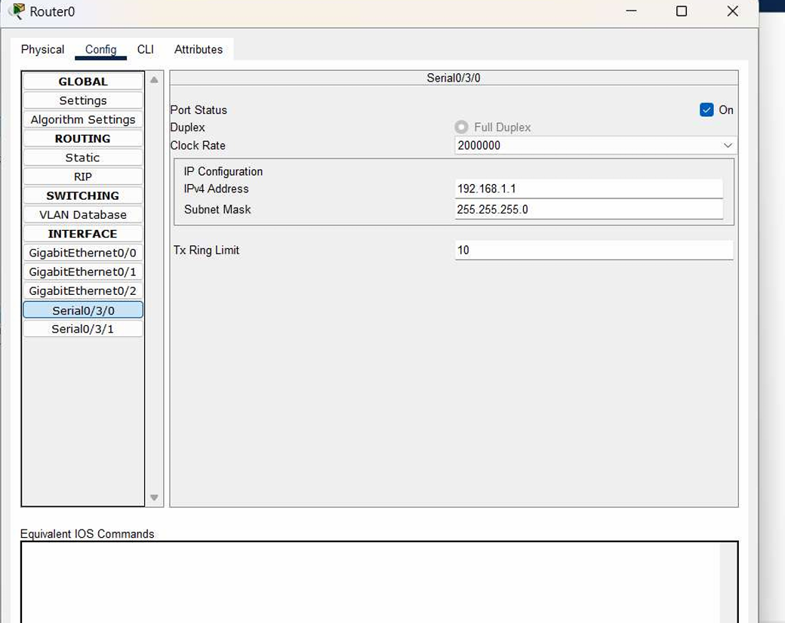

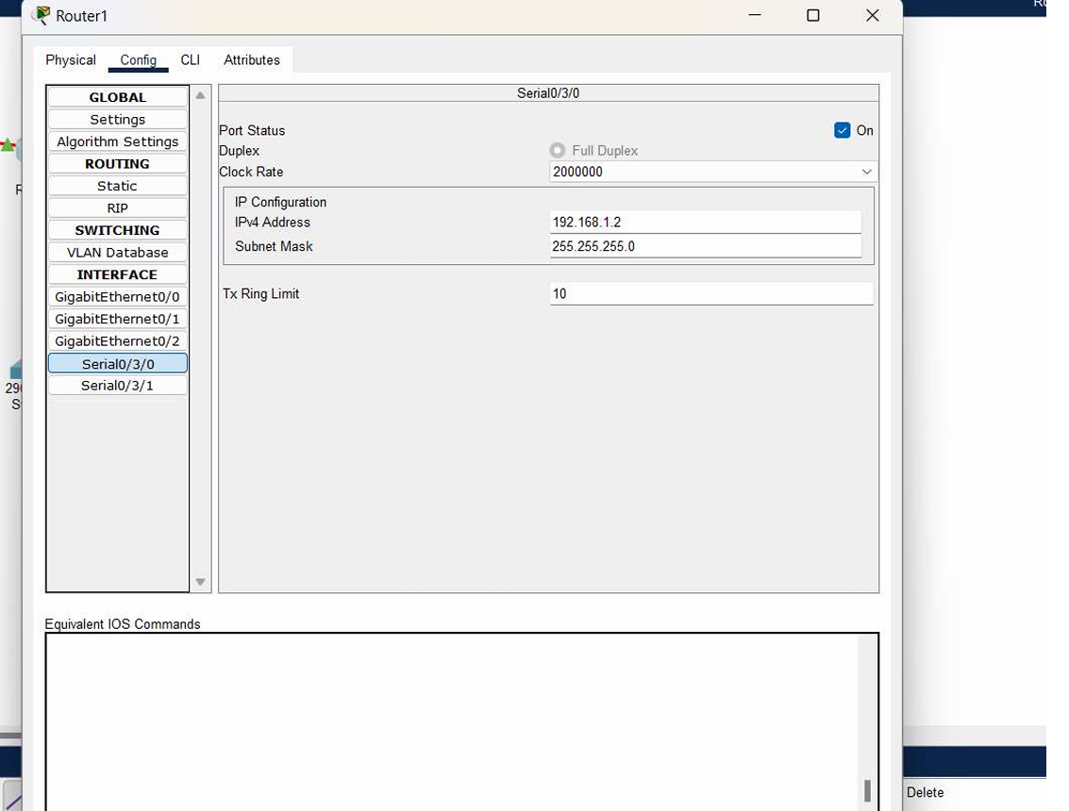

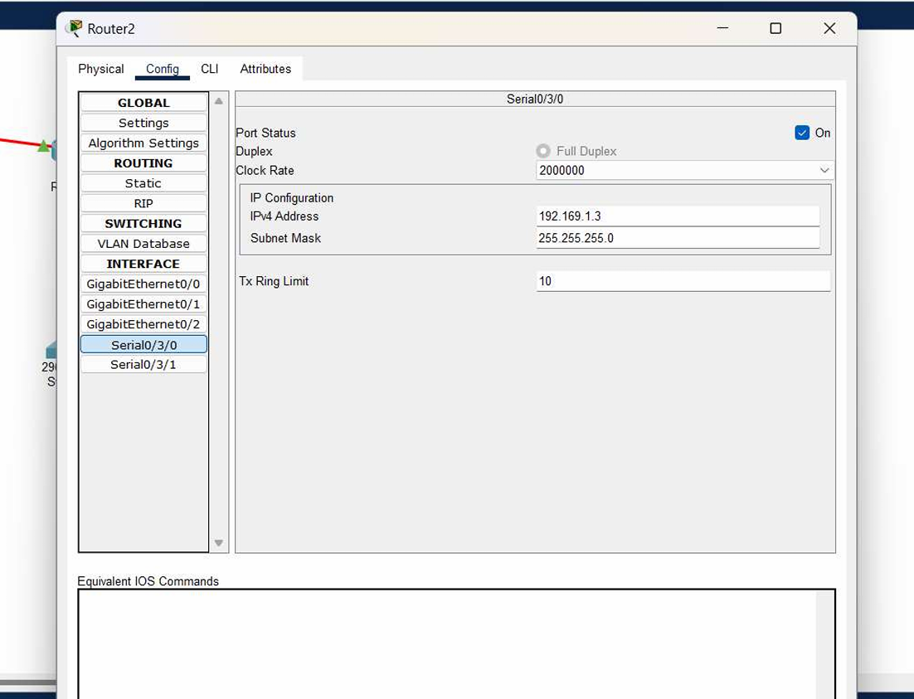

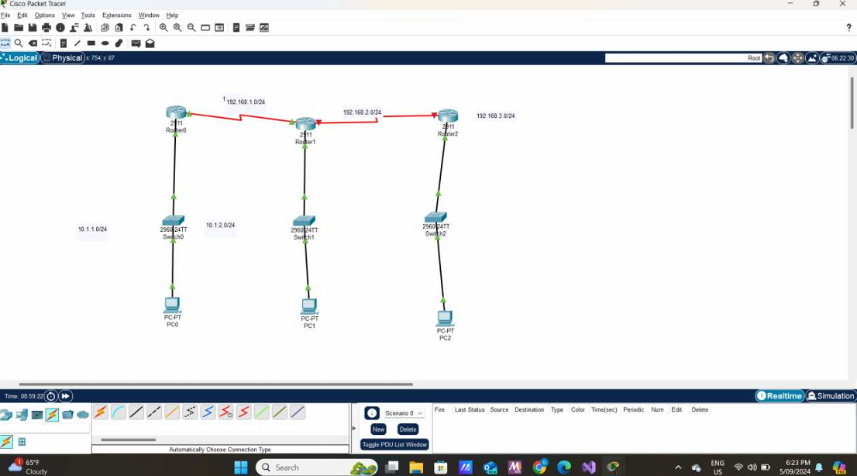

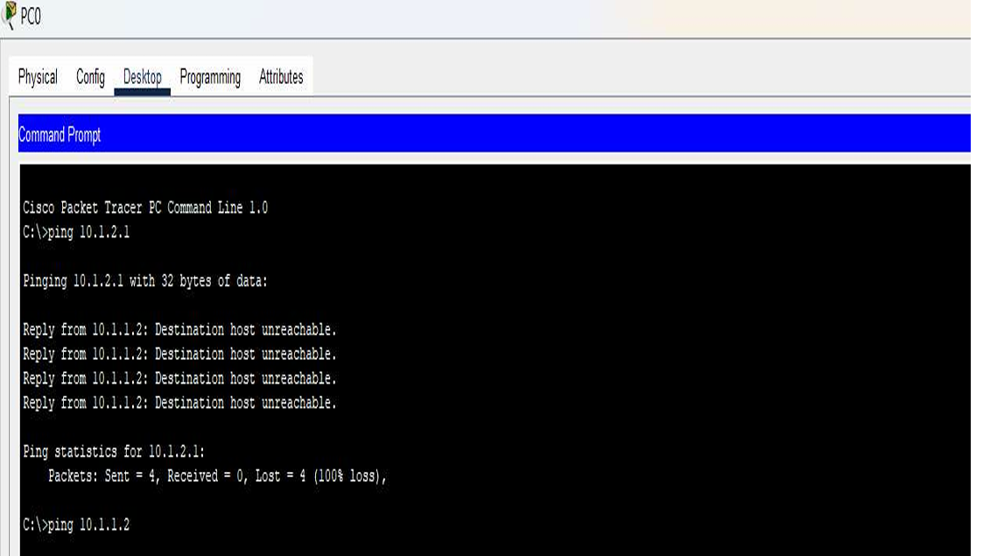

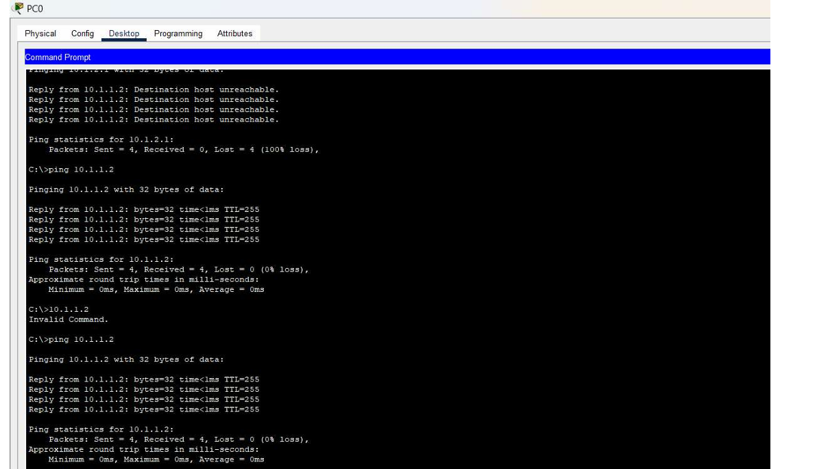

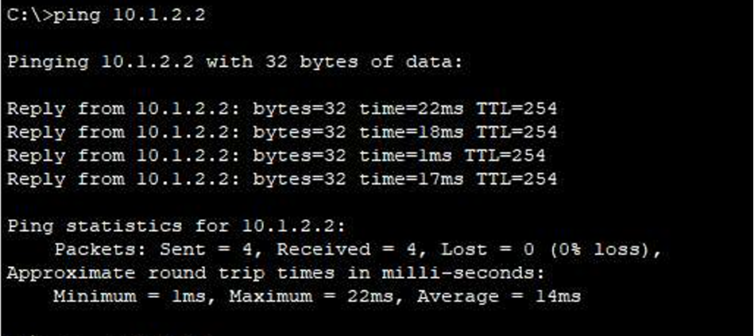

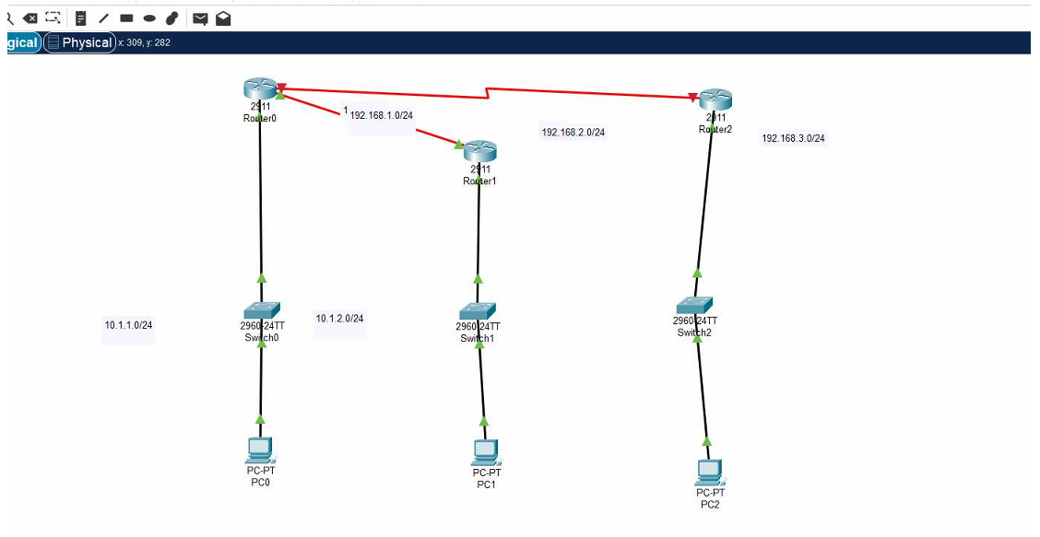

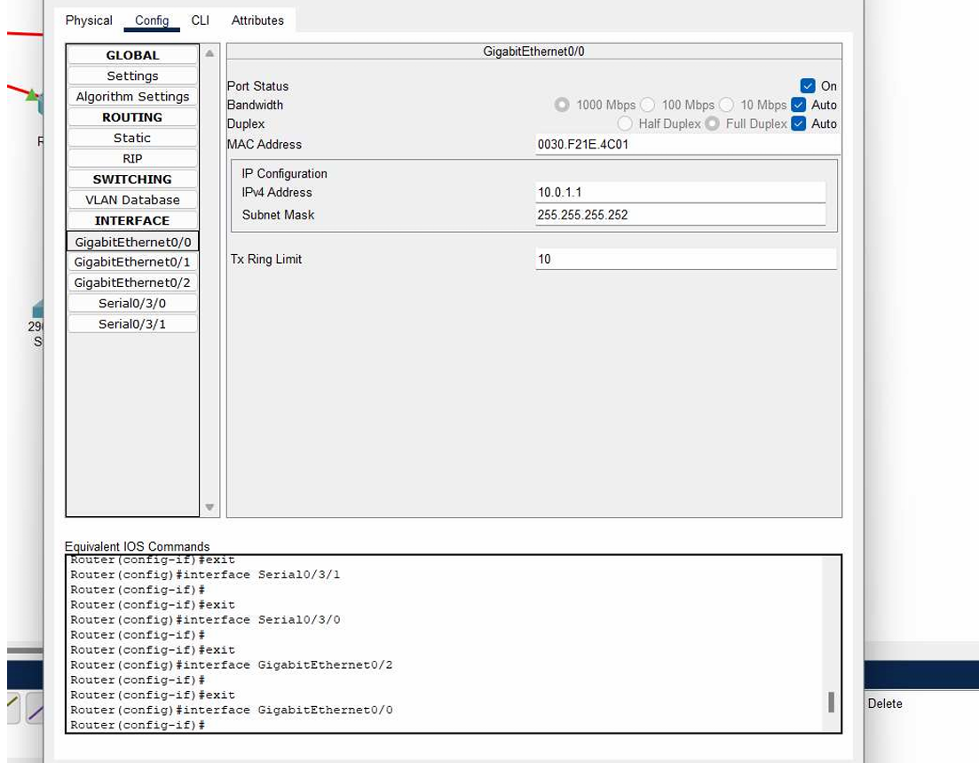

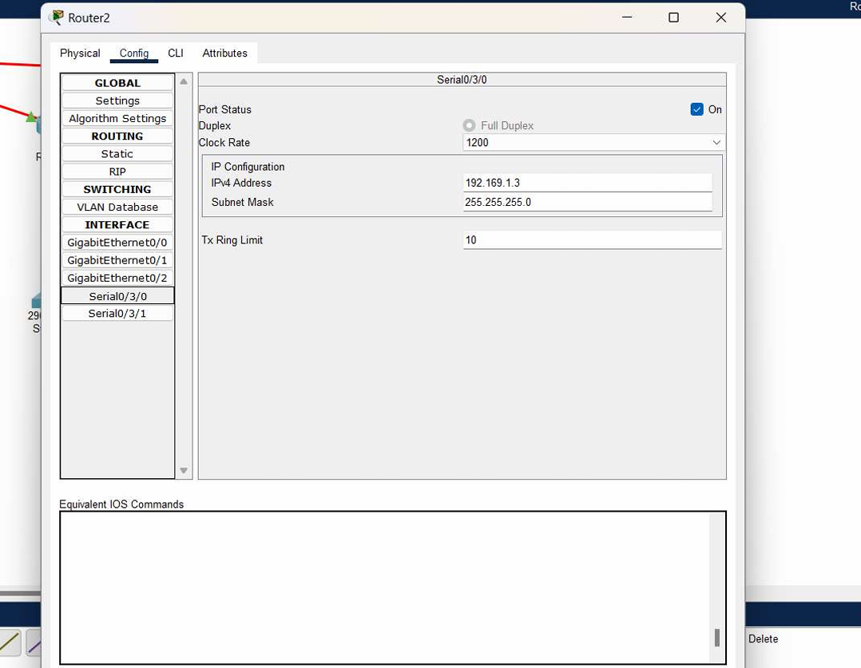

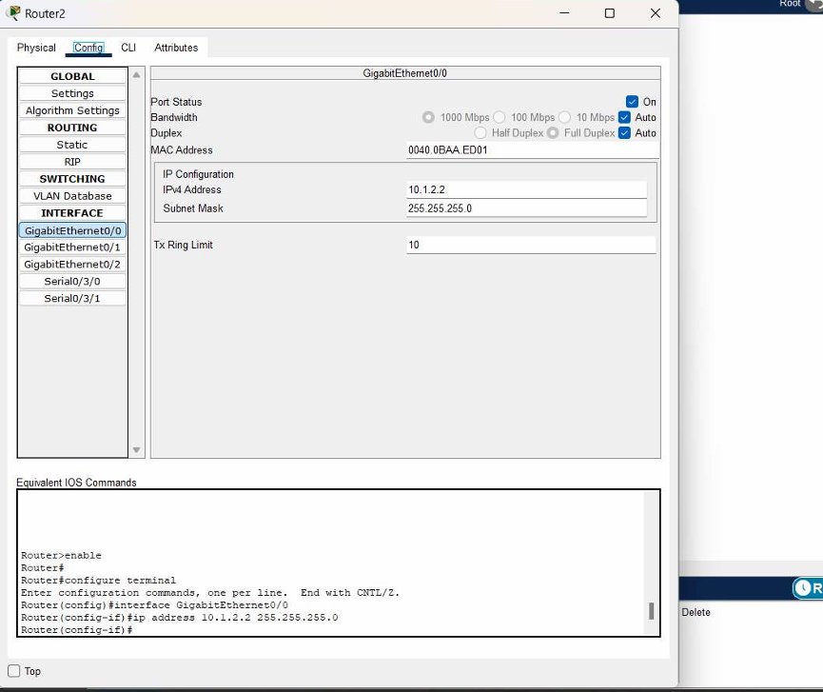

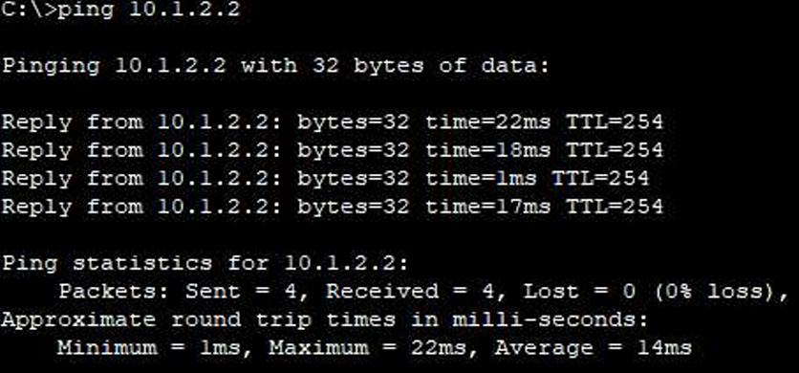

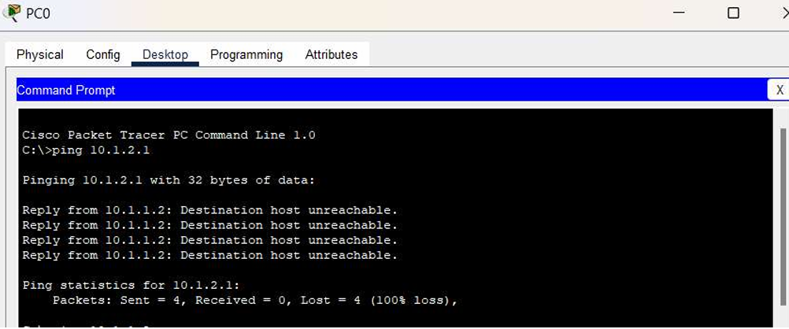

ACTIVITY 3

1. **Is there any alternative to stop manually configuring the routing table every time the connectivity changes?**

**Answer:** Yes, dynamic routing protocols can automate routing table updates. These protocols adjust the routing paths automatically as the network topology changes, reducing the need for manual intervention. For example:

- **RIP (Routing Information Protocol):** Updates routing tables every 30 seconds and uses a simple distance-vector method.

- **OSPF (Open Shortest Path First):** Uses a link-state approach to provide more efficient and scalable routing, particularly in larger networks.

- **EIGRP (Enhanced Interior Gateway Routing Protocol):** Combines features of both distance-vector and link-state protocols, offering fast convergence and support for complex network environments.

2. **What are the latest routing algorithms you can use?**

**Answer:** Some of the most current routing algorithms include:

- **OSPFv3 (Open Shortest Path First version 3):** An enhancement of OSPF designed for IPv6 networks, it improves scalability and efficiency by maintaining a detailed network topology and using Dijkstra's algorithm to calculate the shortest path.

- **BGP-4 (Border Gateway Protocol version 4):** The standard for inter-domain routing on the Internet. It’s used for exchanging routing information between different autonomous systems (ASes) and is crucial for managing large-scale routing tables.

- **EIGRP (Enhanced Interior Gateway Routing Protocol):** A Cisco proprietary protocol that provides faster convergence and supports both IPv4 and IPv6, using a hybrid approach to routing that combines elements of distance-vector and link-state protocols.

3. **Is there any routing algorithm available in Cisco Packet Tracer?**

**Answer:** Yes, Cisco Packet Tracer supports several routing algorithms:

- **RIP v1/v2:** Allows for simple, distance-vector routing with basic configurations.

- **OSPFv2:** Provides a more scalable and efficient link-state routing option for IPv4 networks.

- **EIGRP:** Offers a robust, advanced routing protocol with rapid convergence and support for both IPv4 and IPv6.

HERE ARE THE SCREENSHOTS OF ROUTER 0 , 1 , 2

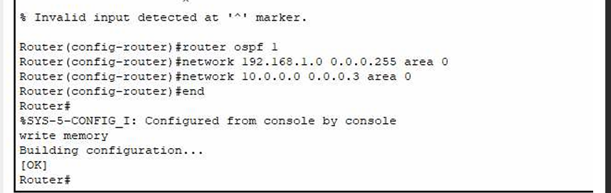

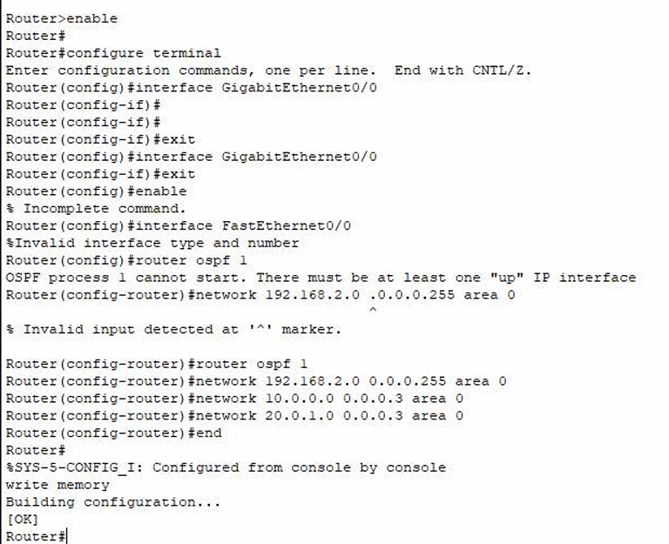

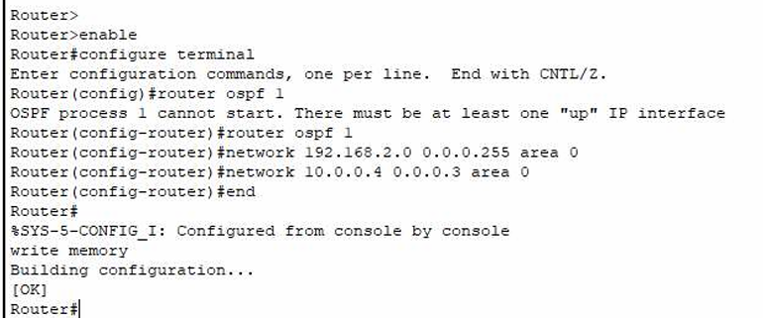

BELOW ATTACHED ARE THE SCREENSHOTS FOR NETWORK COMMUNUCATION USING PING

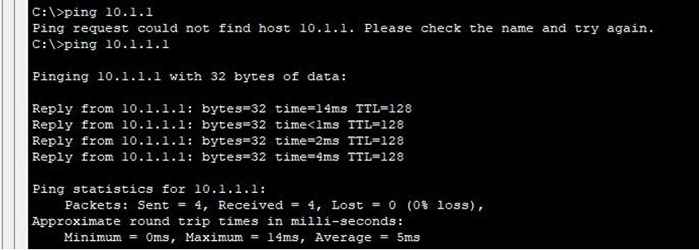

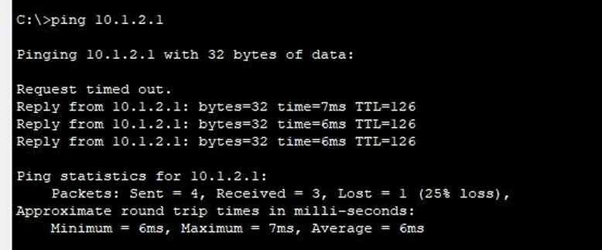

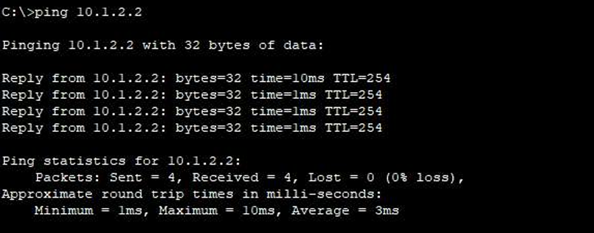

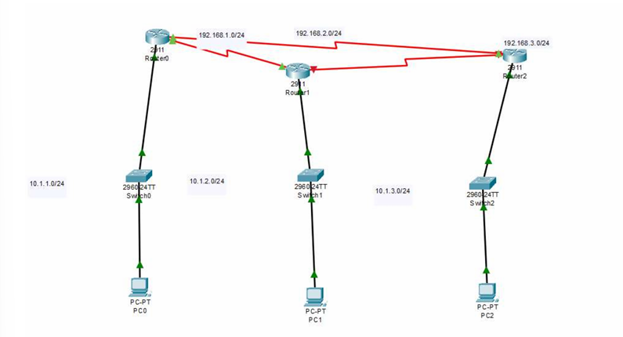

ACTIVE CLASS WEEK 8:

ACTIVITY 1

**1. Do we have enough IP addresses to assign for each device connected to the network?**

**Answer:** The IPv4 address space, which offers around 4.3 billion unique addresses, is insufficient to meet the growing demand for IP addresses from an increasing number of devices, including IoT devices. Given that the number of IoT devices is expected to reach 50 billion soon, the IPv4 address space is inadequate to accommodate this vast number of devices.

**2. Do we have any solution?**

**Answer:** Yes, the primary solution to address the shortage of IP addresses is to transition to **IPv6**. IPv6 provides a vastly larger address space, offering approximately 340 undecillion (3.4 x 10^38) unique IP addresses. This expanded address space ensures that each device can have a unique IP address, solving the limitation of IPv4.

**3. Explain a protocol that we can use along with IPv4 to conserve the global IP address space.**

**Answer:** One effective protocol used alongside IPv4 to conserve the global IP address space is **Network Address Translation (NAT)**.

**Network Address Translation (NAT):**

- **Purpose:** NAT allows multiple devices on a local network to share a single public IP address when accessing external networks, such as the Internet. This is achieved by translating private IP addresses used within the local network into a single public IP address.

- **How It Works:** In a typical NAT configuration, devices within a private network (using IP addresses in ranges like 192.168.x.x, 10.x.x.x, or 172.16.x.x to 172.31.x.x) communicate with the outside world through a NAT-enabled router. The router maintains a table mapping each internal IP address to a single external IP address and port number. When internal devices send requests to the Internet, NAT modifies the outgoing packets to use the public IP address and keeps track of the responses, ensuring they are routed back to the correct internal device.

- **Benefits:** NAT conserves the number of public IP addresses needed by enabling multiple devices to share a single IP address. This is particularly useful for managing and scaling large networks with numerous devices while preserving the limited IPv4 address space.

ACTIVITY 2

### DHCP Communication Role Play and Timing Diagram

**Network Setup and Role Assignment:**

1. **Ekam 1 (Router):** Acts as the router with a DHCP server.

2. **Ekam 2 (Switch):** Manages the switch connecting all devices.

3. **Ekam 3 (PC):** Represents a PC device seeking an IP address.

4. **Ekam 4 (Printer):** Acts as a printer device seeking an IP address.

5. **Ekam 5 (Network Storage Device):** Serves as a network storage device seeking an IP address.

**Timing Diagram for DHCP Message Exchange:**

1. **Ekam 1 (Router):** Sends a **DHCPDISCOVER** message to find available DHCP clients.

2. **Ekam 2 (Switch):** Receives the **DHCPDISCOVER** and forwards it to all devices on the network.

3. **Ekam 3 (PC):** Receives the **DHCPDISCOVER** and responds with a **DHCPOFFER** message.

4. **Ekam 2 (Switch):** Forwards the **DHCPOFFER** from the PC to the DHCP server (Ekam 1).

5. **Ekam 1 (Router):** Receives the **DHCPOFFER** and sends a **DHCPREQUEST** message to request an IP address.

6. **Ekam 4 (Printer):** Receives the **DHCPREQUEST** and responds with a **DHCPACK** message, confirming IP address allocation.

7. **Ekam 5 (Network Storage Device):** Receives the IP address from the **DHCPACK** message and establishes network connectivity.

**Steps for Implementation in Cisco Packet Tracer:**

1. **Set Up Network:**

- **Ekam 1 (Router):** Configure with DHCP server functionality and a fast Ethernet port to support multiple LANs.

- **Ekam 2 (Switch):** Connect all devices to the switch to enable communication.

- **Devices:** Ensure PCs, printers, and network storage devices are physically connected and configured to use DHCP.

QUES 1

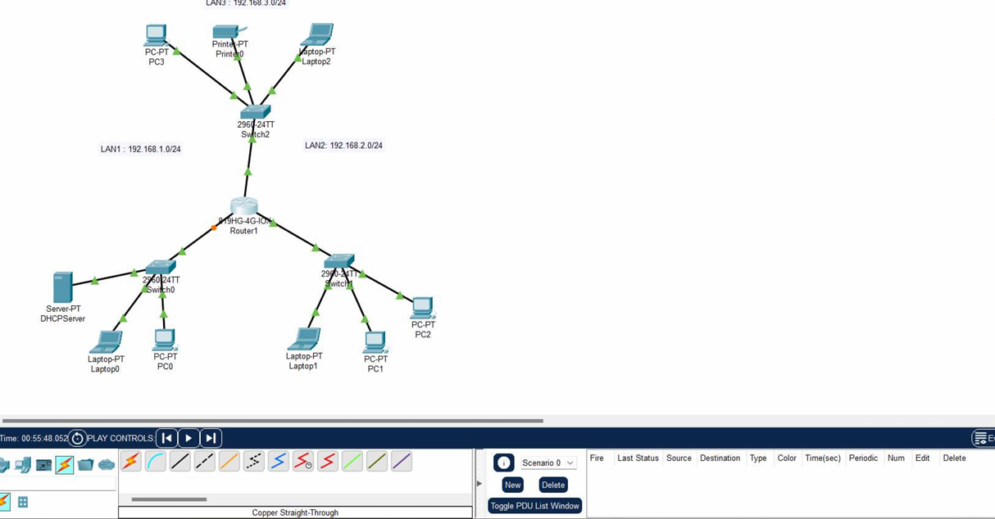

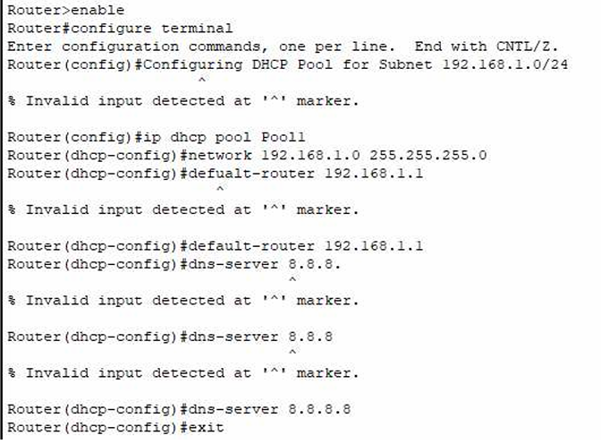

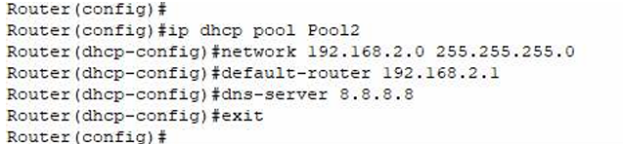

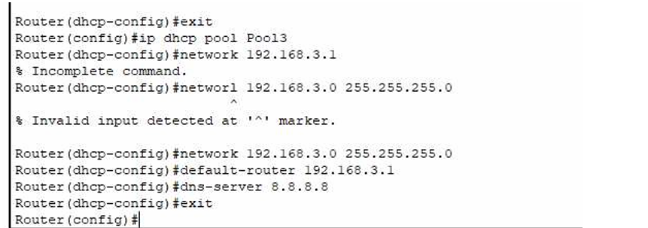

QUES 2

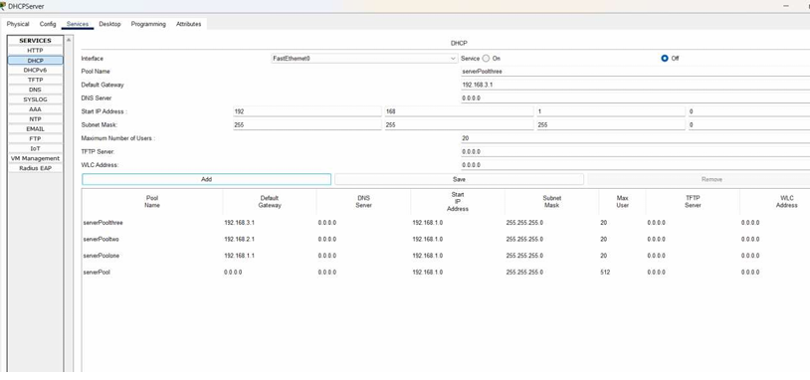

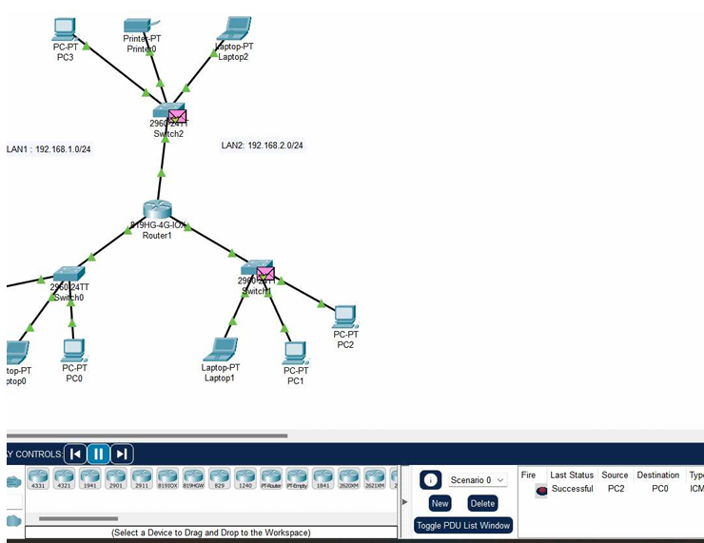

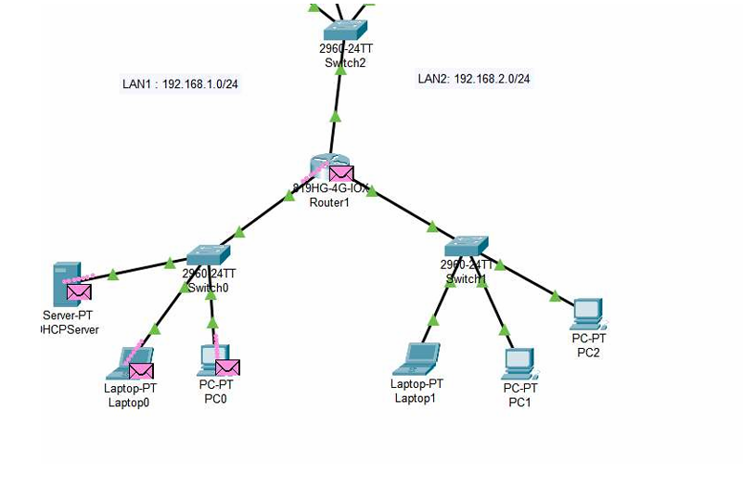

ACTIVITY 3

QUES 1

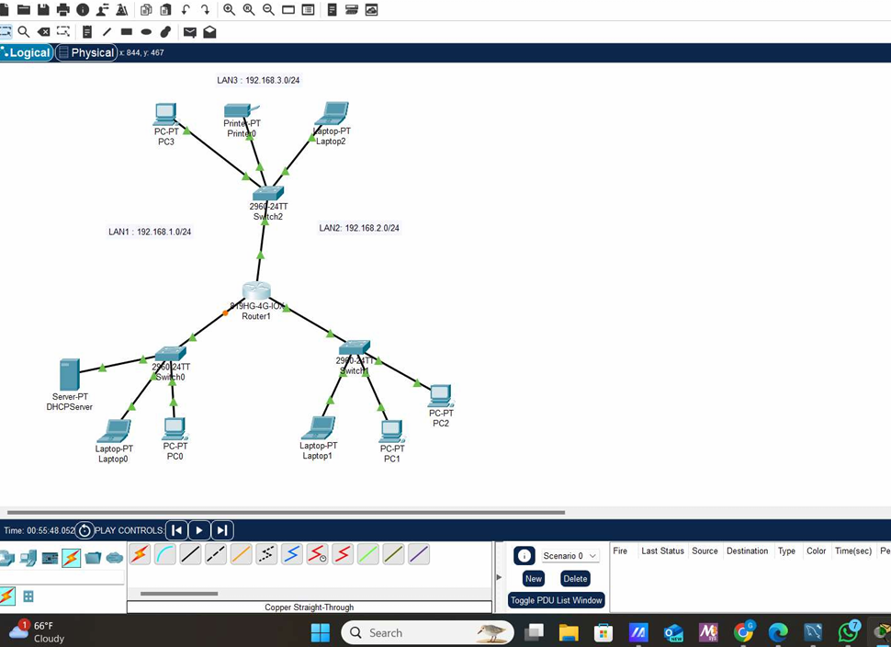

QUES 2

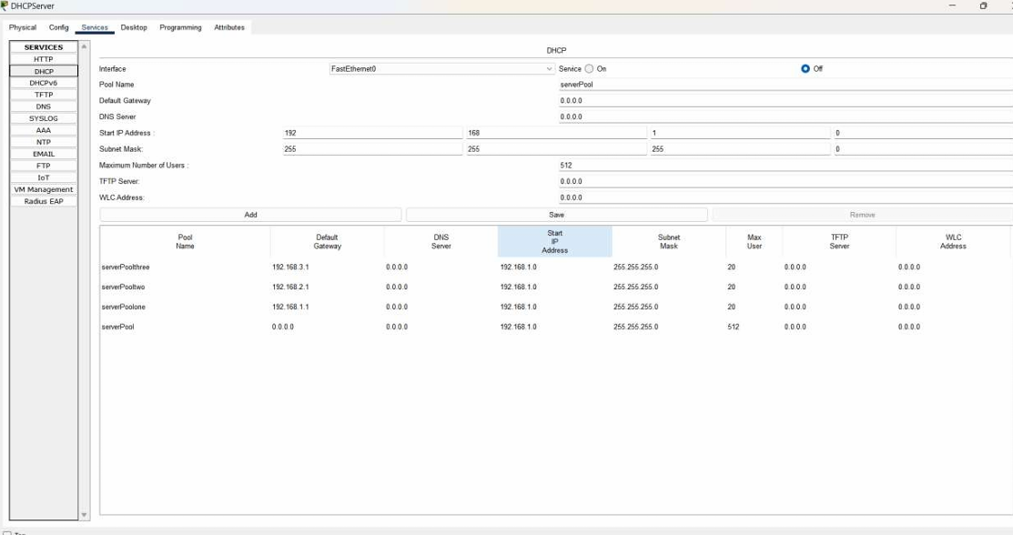

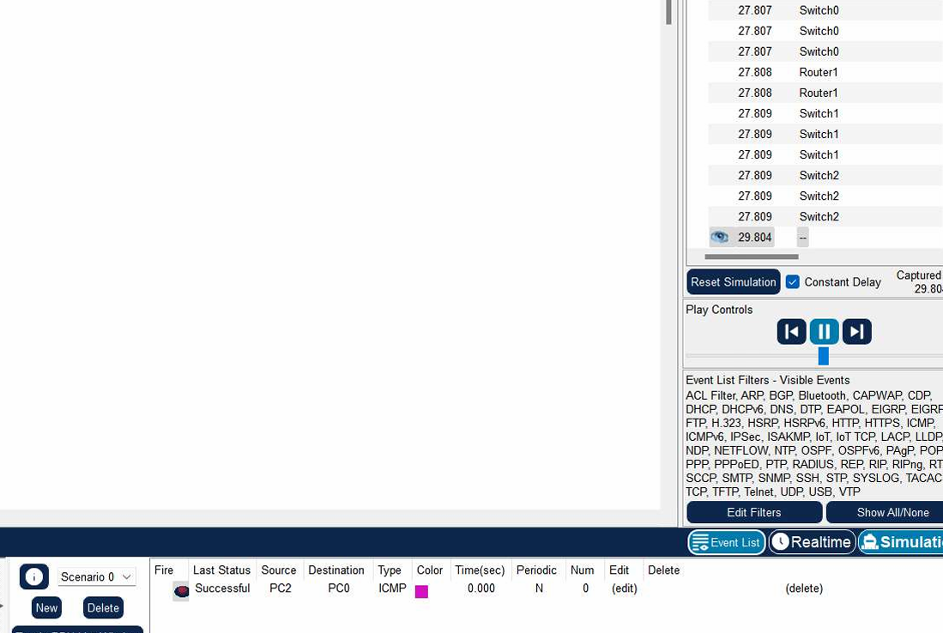

QUES 3 AND 4

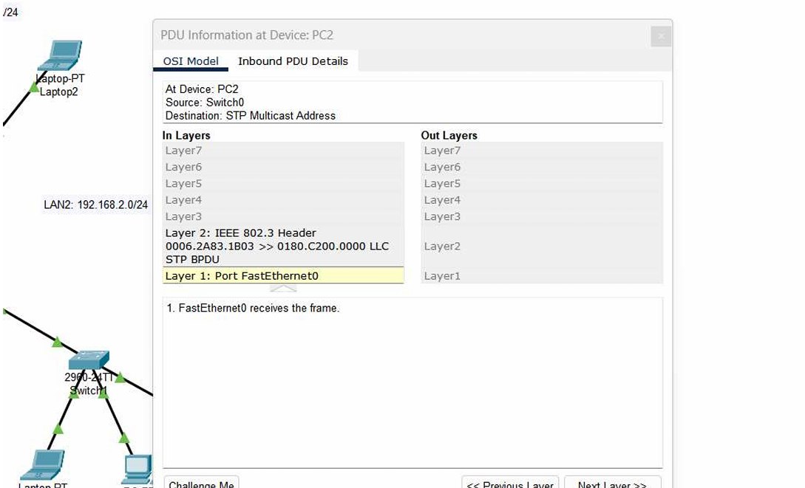

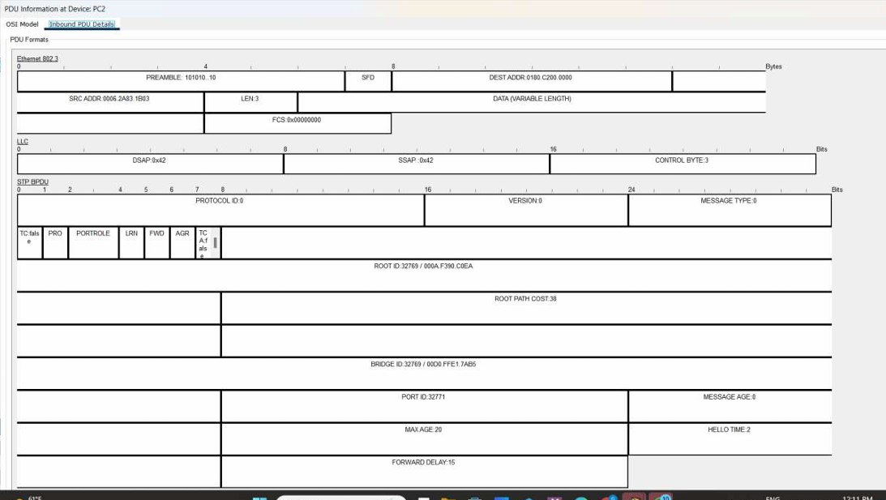

QUES 5 AND 6

### **ICMP Message Format and Details**

**ICMP Message Structure:**

The Internet Control Message Protocol (ICMP) message format includes the following components:

1. **Type:** Specifies the ICMP message type (e.g., Echo Request, Echo Reply).

2. **Code:** Provides additional context or specifics related to the Type (e.g., Code 0 for "Network Unreachable" under Type 3 (Destination Unreachable)).

3. **Checksum:** Used for error-checking to verify that the message has not been altered.

4. **Identifier:** Helps correlate requests and replies, especially for Echo Request and Echo Reply messages.

5. **Sequence Number:** Distinguishes between multiple messages or packets of the same type.

6. **Data:** Contains further details relevant to the specific ICMP message type, such as the payload included in Echo Requests and Replies.

**ICMP Message Types:**

- **Type 0:** Echo Reply

- **Type 3:** Destination Unreachable

- **Type 8:** Echo Request

- **Type 11:** Time Exceeded (used by traceroute to report each hop)

### **Differences in ICMP Messages for Ping and Traceroute**

**Ping:**

- **Type:** 8 for Echo Request, 0 for Echo Reply.

- **Code:** Generally 0 for both Echo Requests and Echo Replies.

- **Function:** Tests connectivity to a host and measures the round-trip time for messages.

**Traceroute:**

- **Type:** 11 for Time Exceeded, which is sent by routers when a packet's TTL (Time-to-Live) expires.

- **Code:** Typically 0 for TTL Expired in Transit.

- **Function:** Maps the route taken by packets from source to destination by incrementally increasing the TTL value and capturing the Time Exceeded messages from intermediate routers.

### **Behavioral Differences between Traceroute and Ping**

- **Ping:** Sends Echo Request packets to the destination and waits for Echo Reply packets to check if the host is reachable and to gauge the round-trip time.

- **Traceroute:** Sends packets with gradually increasing TTL values. Each router along the path reduces the TTL, and when it reaches zero, the router responds with an ICMP Time Exceeded message. This helps in determining the route and identifying each hop from source to destination.